
BRAF (V600M)
Catalog Number: CR-M26462
Gene Symbol: BRAF, BRAF1, RAFB1
Description: Anti-BRAF (V600M) Mouse Monoclonal Antibody
Background: BRAF belongs to a family of serine-threonine protein kinases. As a part of a signaling pathway known as the the RAS/MAPK pathway, it plays an important part in many cellular processes. The processes include cell proliferation, differentiation and transcriptional regulation. Mutations in the BRAF gene cause diseases. Inherited mutations in BRAF cause cardiofaciocutaneous syndrome.
Acquired mutations in BRAF have been found in cancers.

Immunogen: A synthetic peptide from the internal region of BRAF which includes the mutation of V600M, human origin.

Tested applications: ELISA, IF, IHC

Recommended dilutions:
ELISA: 1:1000-1:5000
IF: 1:50-1:100
IHC: 1:50-1:100

Concentration: 1 mg/ml

Host: Mouse

Clonality: Monoclonal

Purity: Purified from ascites

Format: Liquid

Storage buffer:
Preservative: no
Constituents: PBS (without Mg2+ and Ca2+), pH 7.4, 150 mM NaCl, 50% glycerol

Species Reactivity: Recognizes V600M mutant, but not wild-type BRAF of vertebrates.

Storage Conditions: Store at -20°C. Avoid freeze / thaw cycles.
For research use only. Not for diagnostic or therapeutic applications.

Immunofluorescence:

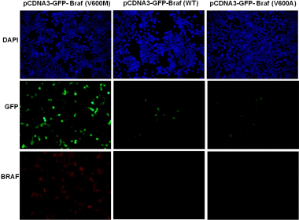
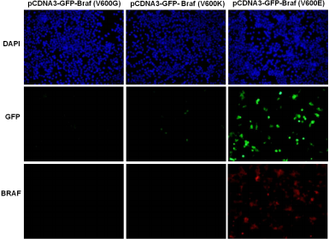
Immunofluorescence of cells expressing BRAF proteins with anti-BRAF (V600M) antibody.
HEK293T cells were transfected with pCDNA3-GFP-BRAF (V600M) plasmid, pCDNA3-GFP-BRAF (WT) plasmid,
pCDNA3-GFP-BRAF (V600A) plasmid,
pCDNA3-GFP-BRAF (V600G) plasmid,
pCDNA3-GFP-BRAF (V600K) plasmid
or pCDNA3-GFP-BRAF (V600E) plasmid
, then fixed and stained with anti-BRAF (V600M) monoclonal antibody (Cat. #26462).

